Birtley East Community Primary School 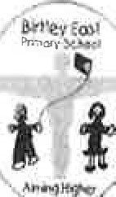
Consent form for school trips and other off-site activities
Please sign and date the form below if you are happy for your child, .....
- To take part in school trips and other activities that take place off school premises; and
- To be given first aid or urgent medical treatment during any school trip or activity
Please note the following important information before signing this form:
  - The trips and activities covered by this consent include; o all visits (including residential trips) which take place during the holidays or a weekend o adventure activities at any time o off-site sporting fixtures outside the school day, o all off-site activities for nursery schools.
  - The school will send you information about each trip or activity before it takes place.
  - You can, if you wish, tell the school that you do not want your child to take part in any particular school trip or activity.
Written parental consent will not be requested from you for the majority of off-site activities offered by the school — for example, year-group visits to local amenities — as such activities are part of the school's curriculum and usually take place during the normal school day.
Please complete the medical information section below (if applicable) and sign and date this form if you agree to the above.
Medical information
Details of any medical condition that my child . suffers from and any medication my child should take during off-site visits:

Signed (parent/carer) Date
Please print your name:....
Please return this completed form to school as soon as possible. We will hold this on your child's records for the duration of their time as a pupil in our school unless you make a request to amend the details you have provided to us whereupon we will update our records accordingly.

