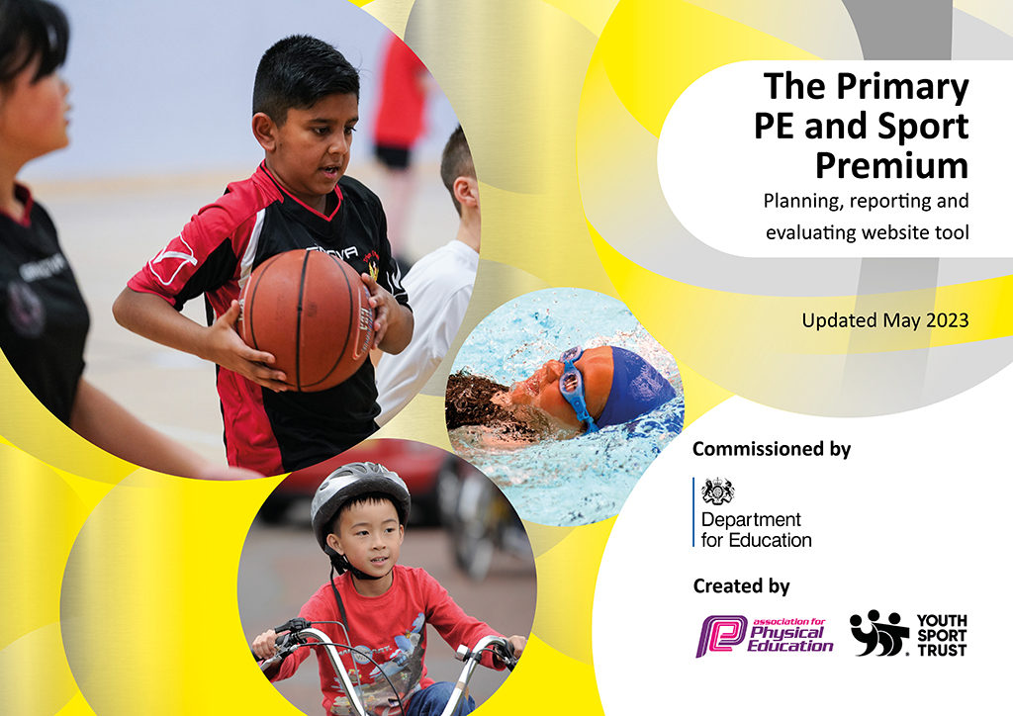
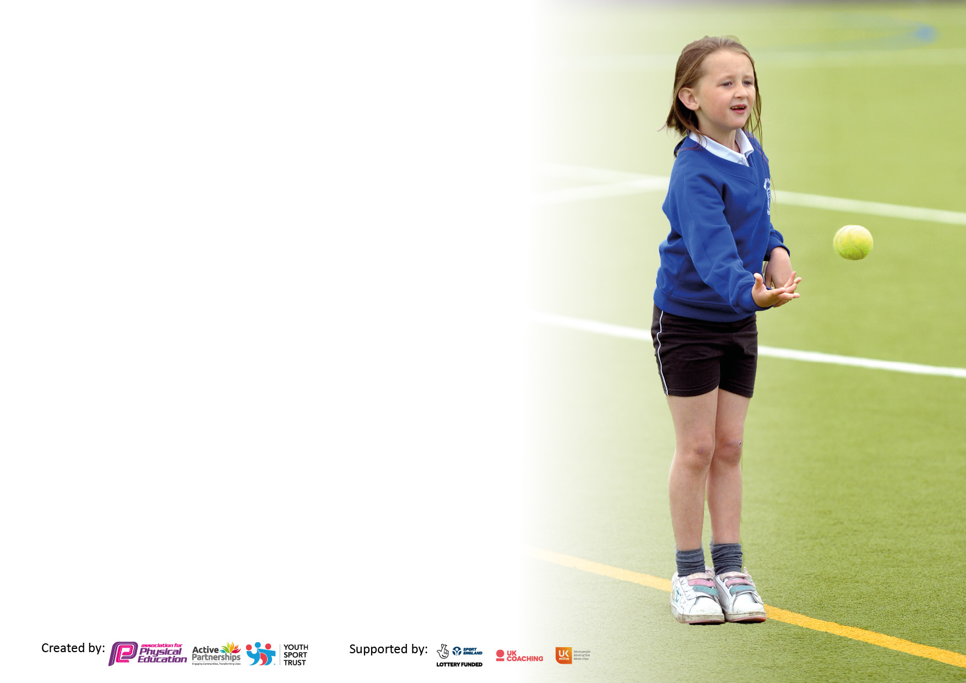

It is important that your grant is used effectively and based on school need. The Education Inspection Framework makes clear there will be a focus on ‘whether leaders and those responsible for governors all understand their respective roles and perform these in a way that enhances the effectiveness of the school’.

Under the Quality of Education judgement, Ofsted inspectors consider:
Intent - Curriculum design, coverage and appropriateness
Implementation - Curriculum delivery, teaching (pedagogy) and assessment
Impact - Attainment and progress

To assist schools with common transferable language, this template has been developed to utilise the same three headings which should make your plans easily transferable between working documents.

Schools must use the funding to make additional and sustainable improvements to the quality of Physical Education, School Sport and Physical Activity (PESSPA) they offer. This means that you should use the Primary PE and sport premium to:

- Develop or add to the PESSPA activities that your school already offers
- Build capacity and capability within the school to ensure that improvements made now will benefit pupils joining the school in future years
- The Primary PE and sport premium should not be used to fund capital spend projects; the school’s budget should fund these.

Please visit https://www.gov.uk/guidance/pe-and-sport-premium-for-primary-schools for the revised DfE guidance, including the 5 key indicators across which schools should demonstrate an improvement. This document will help you to review your provision and to report your spend. DfE encourages schools to use this template as an effective way of meeting the reporting requirements of the Primary PE and Sport Premium.

We recommend you start by reflecting on the impact of current provision and reviewing the previous spend.

Schools are required to publish details of how they spend this funding, including any underspend from 2021/2022, as well as on the impact it has on pupils’ PE and sport participation and attainment.

We recommend regularly updating the table and publishing it on your website throughout the year. This evidences your ongoing self-evaluation of how you are using the funding to secure maximum, sustainable impact. Final copy must be posted on your website by the end of the academic year and no later than the 31 July 2023.

Details with regard to funding
Please complete the table below.

Total amount carried over from 2022/23 | £0
Total amount allocated for 2023/24 | £17,742
How much (if any) do you intend to carry over from this total fund into 2023/24? | £0
Total amount allocated for 2023/24 | £17,742
Total amount of funding for 2023/24 to be reported on by 31st July 2024 | £ 17,742
Swimming Data
Please report on your Swimming Data below.

Meeting national curriculum requirements for swimming and water safety.

N.B. Complete this section as best you can. For example, you might have practised safe self-rescue techniques on dry land which you can then transfer to the pool when school swimming restarts.
Due to exceptional circumstances priority should be given to ensuring that pupils can perform safe self-rescue even if they do not fully meet the first two requirements of the NC programme of study
What percentage of your current Year 6 cohort swim competently, confidently and proficiently over a distance of at least 25 metres?  N.B. Even though your pupils may swim in another year, please report on their attainment on leaving primary school at the end of the summer term 2023.  Please see note above | 86%
What percentage of your current Year 6 cohort use a range of strokes effectively [for example, front crawl, backstroke and breaststroke]?  Please see note above | 61%
What percentage of your current Year 6 cohort perform safe self-rescue in different water-based situations? | 100%
Schools can choose to use the Primary PE and sport premium to provide additional provision for swimming, but this must be for activity over and above the national curriculum requirements. Have you used it in this way? | Yes/No (top-up swimming not offered due to the closure of the leisure centres and inconsistency in swimming lessons which is still evident)

Action Plan and Budget Tracking
Capture your intended annual spend against the 5 key indicators. Clarify the success criteria and evidence of impact that you intend to measure to evaluate for pupils today and for the future.

Academic Year: 2023/24 | Total fund allocated: | Date Updated:
Key indicator 1: Increase confidence, knowledge and skills of all staff in teaching PE and sport |  |  |  | Percentage of total allocation:
 |  |  |  | 1%
Intent | Implementation |  | Impact
Your school focus should be clear on what you want the pupils to know and be able to do. What do they need to learn and to consolidate through practice: | Make sure your actions to achieve are linked to your intentions: | Funding allocated: | Evidence of impact:  What do pupils now know and what can they now do? What has changed? | Sustainability and suggested next steps:
Teacher knowledge and confidence support.  To improve the teaching and learning of gymnastics throughout school and as an extra-curricular activity. | Membership of Complete PE scheme to aid teaching and learning and support progression in PE lessons.  Monique Riley to attend 2 day intermediate gymnastics instructor course through and part funded by GSSP | £150  £50 (additional £200 to be paid by GSSP) | Higher level of teaching and learning and progression across school in all areas of sport. Teaching aids and videos for areas with less staff confidence. Positive feedback so far from staff.  Higher level of teaching and learning and progression across school in gymnastics. MB to offer advice and support to other staff if appropriate. | We will always have access but membership allows us to receive new content. Staff to use alongside own judgement.  Consider utilizing MB to lead gymnastics teaching across school.
Key indicator 2: The engagement of all pupils in regular physical activity – Chief Medical Officers’ guidelines recommend that  primary school pupils undertake at least 30 minutes of physical activity a day in school |  |  |  | Percentage of total allocation:
 |  |  |  | 9%
Intent | Implementation |  | Impact
Your school focus should be clear on what you want the pupils to know and be able to do. What do they need to learn and to consolidate through practice: | Make sure your actions to achieve are linked to your intentions: | Funding allocated: | Evidence of impact:  What do pupils now know and what can they now do? What has changed? | Sustainability and suggested next steps:
Participation in mile per day to build up children’s fitness levels and enable them to run at a sustained steady pace, increasing over time.  Children are active outside and encouraged to use the whole site at all times of year. Spend money to replace equipment and fill sand pit.  Increase the amount of time children are active as well as improving brain activity and academic success. | Every class to complete it each day, when appropriate.  Children active outside and rarely have indoor play unless the rain is torrential.  Implement Teach Active resource across school in Maths and/or English | Nil  £500  £1150 (£575 for each subject) | Improved fitness seen over time. Children who always push themselves during the mile excelled at cross country.  Active, imaginative children who are all busy and improves behavior outside.  Children to increase the amount of time they are active and at the same time improve their academic ability and retention of information. | Continue to encourage mile per day.  Well sustained.  Staff to gain ideas and resources for further teaching.

Key indicator 3: The profile of PE and sport is raised across the school as a tool for whole school improvement |  |  |  | Percentage of total allocation:
 |  |  |  | 17%
Intent | Implementation |  | Impact
Your school focus should be clear on what you want the pupils to know and be able to do. What do they need to learn and to consolidate through practice: | Make sure your actions to achieve are linked to your intentions: | Funding allocated: | Evidence of impact:  What do pupils now know and what can they now do? What has  changed? | Sustainability and suggested next steps:
Suitable equipment available to enhance PE in a range of areas. Pupils to have access to and improve their skill using a range of equipment.  Improve the wellbeing of children and staff in school. | Purchase a range of equipment to support and improve PE teaching including competitive size football goals and line marker.  Signed up to GSHW to drive positive wellbeing changes. | £2,000  £1,000 | Higher quality PE lessons being taught with age appropriate equipment available.  Receive support materials and training for both staff and pupils. | Continue to audit and purchase/replace equipment where necessary.  Continue to work towards and put plans in place for our next healthy schools award for 2 years time.
Key indicator 4: Broader experience of a range of sports and physical activities offered to all pupils |  |  |  | Percentage of total allocation:
 |  |  |  | 52%
Intent | Implementation |  | Impact
Your school focus should be clear on what you want the pupils to know and be able to do. What do they need to learn and to consolidate through practice: | Make sure your actions to achieve are linked to your intentions: | Funding allocated: | Evidence of impact:  What do pupils now know and what can they now do? What has  changed? | Sustainability and suggested next steps:
Staff in all year groups to receive training alongside a qualified instructor to teach children how to safely ride their bikes.  Children to showcase their talents in a variety of competitions, festivals and tournaments.  Annual National Trust membership for school.  Fund/part fund educational visits with a focus on physical activity and OAA. | Each year group to have specialised training from a qualified instructor on how to teach children to ride their bikes. Hire bikes included so all children can participate.  Provide coaches to get to various venues.  Class trips to offer a broader range of physical or active experiences for children at National Trust sites.  Staff to plan class trips for children with a focus on physical activity to encourage an active and healthy lifestyle or broaden the children’s experience of physical activities (OAA) | £3,300  (possible additional day with Rich for staff CPD. Cost to be added)  £3,000  £120  £2,822 | Increased staff knowledge to enable staff to teach children to ride bikes.  Children able to attend sporting events free of charge to lessen the financial burden on their families.  Children to receive a broader range of experiences with a focus on physical activity.  Children to receive a broader range of experiences with a focus on physical activity. | Children to be encouraged to learn to ride in school safely to encourage an active lifestyle and travel to school.  Continue to attend a range of events and festivals.  Continue to offer children a range of experiences.  Continue to offer children a range of experiences.

Key indicator 5: Increased participation in competitive sport |  |  |  | Percentage of total allocation:
 |  |  |  | 21%
Intent | Implementation |  | Impact
Your school focus should be clear on what you want the pupils to know and be able to do. What do they need to learn and to consolidate through practice: | Make sure your actions to achieve are linked to your intentions: | Funding allocated: | Evidence of impact:  What do pupils now know and what can they now do? What has  changed? | Sustainability and suggested next steps:
To take part in competitive sport against other schools in the cluster and local authority. To improve skill in a range of sports after coaching from PE specialist from local secondary school before cluster events.  To take part in cluster events (competitive challenge) and sport against children from other schools.  Establish school football team so that children can represent the school.  All children to have appropriate clothing to participate in school sports events. | Affiliate with the SSP to take part in both cluster and LA events.  Buy credits for cluster events led by LLOBA  Children from Year 5/6 to request a place and be chosen on their football skill and commitment.  Waterproof jackets and personalised t-shirts with school logo to be ordered for small group sports events such as cross country | £3,150  £200 affiliation fee  £300 | Children able to develop and improve their skill when playing against other children of the same age. Children developed new and existing skills during sessions with secondary school head of PE.  Children to play competitive sport against other children of the same age to improve and develop their skills.  Children to further improve their skills and feel a sense of pride when representing the school team.  All children to have suitable clothing to attend events – particularly waterproof jackets. | Continue to affiliate with SSP for access to events and support. Sign up for top ups for cluster sessions too next year when changes are implemented.  To continue to provide competitive opportunities for children.  Children eager to play for school team next year so we continue to play in Chester-Le-Street School League.  Clothing will remain as school property to be used for future events.

Signed off by
Head Teacher:
Date:
Subject Leader: | Ruth Small
Date: | 1/12/2023
Governor:
Date:

